**Chapter 5**

**Multiple Integration**

**5.1 Double Integrals over Rectangular Regions**

**Section Exercises**

**In the following exercises, use the midpoint rule with  and  to estimate the volume of the solid bounded by the surface , the vertical planes, , , and, and the horizontal plane .**

1. 

Answer: 27.

**In the following exercises, estimate the volume of the solid under the surface  and above the rectangular region *R* by using a Riemann sum with  and the sample points to be the lower left corners of the subrectangles of the partition.**

3. , 

Answer: 0.

5. Use the midpoint rule with  to estimate , where the values of the function *f* on  are given in the following table.

|  |  |  |  |  |  |
| --- | --- | --- | --- | --- | --- |
|  | ***y*** | | | | |
| ***x*** | 9 | 9.5 | 10 | 10.5 | 11 |
| 8 | 9.8 | 5 | 6.7 | 5 | 5.6 |
| 8.5 | 9.4 | 4.5 | 8 | 5.4 | 3.4 |
| 9 | 8.7 | 4.6 | 6 | 5.5 | 3.4 |
| 9.5 | 6.7 | 6 | 4.5 | 5.4 | 6.7 |
| 10 | 6.8 | 6.4 | 5.5 | 5.7 | 6.8 |

Answer: 21.3.

7. The depth of a children’s 4-ft by 4-ft swimming pool, measured at 1-ft intervals, is given in the following table.

1. Estimate the volume of water in the swimming pool by using a Riemann sum with . Select the sample points using the midpoint rule on .
2. Find the average depth of the swimming pool.

|  |  |  |  |  |  |
| --- | --- | --- | --- | --- | --- |
|  | ***y*** | | | | |
| ***x*** | 0 | 1 | 2 | 3 | 4 |
| 0 | 1 | 1.5 | 2 | 2.5 | 3 |
| 1 | 1 | 1.5 | 2 | 2.5 | 3 |
| 2 | 1 | 1.5 | 1.5 | 2.5 | 3 |
| 3 | 1 | 1 | 1.5 | 2 | 2.5 |
| 4 | 1 | 1 | 1 | 1.5 | 2 |

Answer: a. 28  b. 1.75 ft.

9. The level curves  of the function *f* are given in the following graph, where *k* is a constant.

1. Apply the midpoint rule with  to estimate the double integral , where .
2. Estimate the average value of the function *f* on *R*.

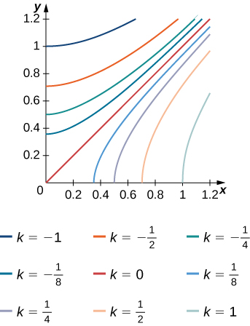

Answer: a. b.; here , , ..,

and .

11. The solid lying under the surface  and above the rectangular region  is illustrated in the following graph. Evaluate the double integral, where , by finding the volume of the corresponding solid.

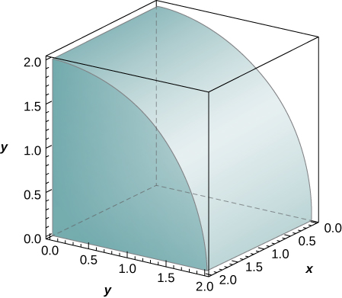

Answer: .

**In the following exercises, calculate the integrals by interchanging the order of integration.**

13. 

Answer: 40.

15. 

Answer: .

17. 

Answer: .

19. 

Answer: 

**In the following exercises, evaluate the iterated integrals by choosing the order of integration.**

21. 

Answer: 0.

23. 

Answer: .

25. 

Answer: .

27. 

Answer: .

29. 

Answer: .

31. 

Answer: .

33. 

Answer: .

**In the following exercises, find the average value of the function over the given rectangles.**

35. , 

Answer: .

37. , 

Answer:.

39. Let *f* and *g* be two continuous functions such that  for any  and  for any . Show that the following inequality is true:.

**In the following exercises, use property v. of double integrals and the answer from the preceding exercise to show that the following inequalities are true.**

41. , where 

Answer: This is a proof; therefore, no answer is provided.

43. , where 

Answer: This is a proof; therefore, no answer is provided.

**In the following exercises, use property v. of double integrals and the answer from the preceding exercise to show that the following inequalities are true.**

45. , where 

Answer: This is a proof; therefore, no answer is provided.

47. , where 

Answer: This is a proof; therefore, no answer is provided.

**In the following exercises, the function *f* is given in terms of double integrals.**

1. **Determine the explicit form of the function *f*.**
2. **Find the volume of the solid under the surface  and above the region *R*.**
3. **Find the average value of the function *f* on *R*.**
4. **Use a computer algebra system (CAS) to plot  and  in the same system of coordinates.**

49. **[T]** , where 

Answer: a.  b.  c. ;

d.

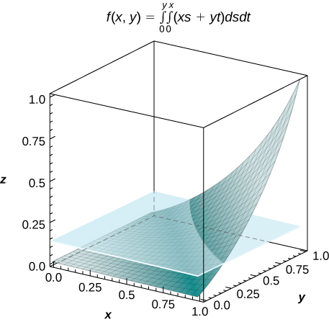

51. Show that if *f* and *g* are continuous on  and , respectively, then

.

Answer: This is a proof; therefore, no answer is provided.

53. **[T]** Consider the function , where .

1. Use the midpoint rule with  to estimate the double integral . Round your answers to the nearest hundredths.
2. For , find the average value of *f* over the region *R*. Round your answer to the nearest hundredths.
3. Use a CAS to graph in the same coordinate system the solid whose volume is given by  and the plane .

Answer: a. For ,  b. ;

c.

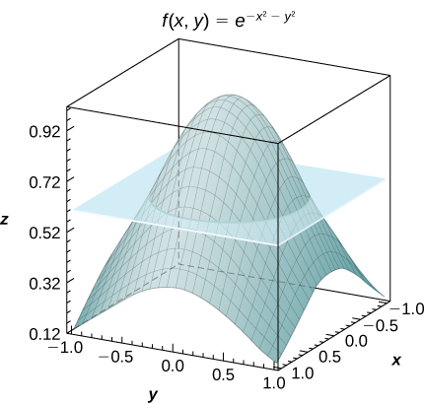

**In the following exercises, the functions ** are given, where  is a natural number.**

1. **Find the volume of the solids  under the surfaces  and above the region *R*.**
2. **Determine the limit of the volumes of the solids  as *n* increases without bound.**

55. 

Answer: a.  b. 

57. Show that the average value of a function *f* on a rectangular region  is , where  are the sample points of the partition of *R*, where  and .

Answer: This is a proof; therefore, no answer is provided.

59. An isotherm map is a chart connecting points having the same temperature at a given time for a given period of time. Use the preceding exercise and apply the midpoint rule with  to find the average temperature over the region given in the following figure.

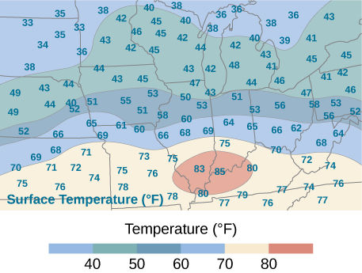

Answer: F ; here , , , , where  and  are the midpoints of the subintervals of the partitions of  and , respectively.

This file is copyright 2016, Rice University. All Rights Reserved.